Assignment 3:Synchronization Problems

# Name – Akshat Chandrapatle Div- CS-A Roll no.- 45 PRN- 12111449

1. Producer consumer using mutex

Code:

#include <stdio.h>

#include <pthread.h>

#include <stdlib.h>

#define BufferSize 10

int count = 0;

int buffer[BufferSize];

pthread_mutex_t mutex;

void *producer(void *item){

long int num = (long int)item;

while(1) {

pthread_mutex_lock(&mutex);

if (count < BufferSize) {

buffer[count] = rand() % 10;

printf(" \n Producer %ld Produced %d\n", num + 1, buffer[count]);

count++;

}

pthread_mutex_unlock(&mutex);

sleep(1);

}

pthread_exit(NULL);

}

void *consumer(void *item){

long int num = (long int)item;

while(1) {

pthread_mutex_lock(&mutex);

if (count > 0) {

count--;

printf(" \n Consumer %ld consumed %d\n", num + 1, buffer[count]);

}

pthread_mutex_unlock(&mutex);

sleep(1);

}

pthread_exit(NULL);

}

int main()

{

printf("Hello World");

pthread_t p[10], c[10];

pthread_mutex_init(&mutex, NULL);

unsigned long int i;

for( i = 0; i < 10; i++) {

pthread_create(&p[i], NULL, producer, (void *)i);

}

for(i = 0; i < 10; i++) {

pthread_create(&c[i], NULL, consumer, (void *)i);

}

for(i = 0; i < 10; i++) {

pthread_join(p[i], NULL);

}

for( i = 0; i < 10; i++) {

pthread_join(c[i], NULL);

}

return 0;

}

Output:

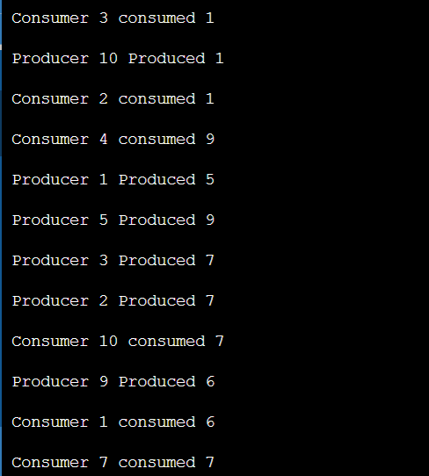

1. Producer consumer using semaphore

Code:

#include <stdio.h>

#include <pthread.h>

#include <semaphore.h>

#include <stdlib.h>

#define BufferSize 10

sem_t empty;

sem_t full;

int count = 0;

int buffer[BufferSize];

void *producer(void *item){

long int num = (long int)item;

while (1) {

int item = rand() % 10;

sem_wait(&empty);

buffer[count]=item;

printf("Producer %ld Produced %d\n", num+1, buffer[count]);

count++;

sem_post(&full);

sleep(1);

}

pthread_exit(NULL);

}

void *consumer(void *item){

long int num = (long int)item;

while (1) {

sem_wait(&full);

count--;

printf("Consumer %ld consumed %d\n", num+1, buffer[count]);

sem_post(&empty);

sleep(1);

}

pthread_exit(NULL);

}

int main()

{

printf("Hello World");

pthread_t p[10],c[10];

sem_init(&empty, 0, BufferSize);

sem_init(&full, 0, 0);

unsigned long int i;

for( i = 0; i < 10; i++) {

pthread_create(&p[i], NULL, producer, (void *)i);

}

for(i = 0; i < 10; i++) {

pthread_create(&c[i], NULL, consumer, (void *)i);

}

for(i = 0; i < 10; i++) {

pthread_join(p[i], NULL);

}

for( i = 0; i < 10; i++) {

pthread_join(c[i], NULL);

}

sem_destroy(&empty);

sem_destroy(&full);

return 0;

}

Output:

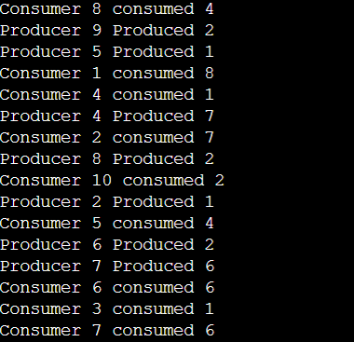

1. Reader writer using semaphore

Code :

#include <stdio.h>

#include <stdlib.h>

#include <pthread.h>

#include <semaphore.h>

#define BUFFER_SIZE 10

int buffer[BUFFER_SIZE];

int reader_count = 0;

sem_t read_sem, write_sem, mutex;

void *writer(void *arg)

{

int data = *(int*)arg;

sem_wait(&write_sem);

buffer[0] = data;

printf("Writer wrote %d\n", data);

sem_post(&write_sem);

pthread_exit(NULL);

}

void *reader(void *arg)

{

int index = *(int*)arg;

sem_wait(&mutex);

reader_count++;

if (reader_count == 1)

sem_wait(&write_sem);

sem_post(&mutex);

sem_wait(&read_sem);

printf("Reader %d read %d\n", index, buffer[0]);

sem_post(&read_sem);

sem_wait(&mutex);

reader_count--;

if (reader_count == 0)

sem_post(&write_sem);

sem_post(&mutex);

pthread_exit(NULL);

}

int main()

{

pthread_t writers[3], readers[5];

sem_init(&read_sem, 0, 1);

sem_init(&write_sem, 0, 1);

sem_init(&mutex, 0, 1);

int i;

for (i = 0; i < 3; i++)

pthread_create(&writers[i], NULL, writer, &i);

for (i = 0; i < 5; i++)

pthread_create(&readers[i], NULL, reader, &i);

for (i = 0; i < 3; i++)

pthread_join(writers[i], NULL);

for (i = 0; i < 5; i++)

pthread_join(readers[i], NULL);

sem_destroy(&read_sem);

sem_destroy(&write_sem);

sem_destroy(&mutex);

return 0;

}

Output:

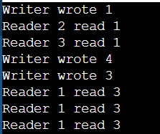

1. Reader writer using mutex

Code:

#include <stdio.h>

#include <stdlib.h>

#include <pthread.h>

#define BUFFER_SIZE 10

int buffer[BUFFER_SIZE];

int reader_count = 0;

pthread_mutex_t mutex = PTHREAD_MUTEX_INITIALIZER;

void *writer(void *arg)

{

int data = *(int*)arg;

pthread_mutex_lock(&mutex);

buffer[0] = data;

printf("Writer wrote %d\n", data);

pthread_mutex_unlock(&mutex);

pthread_exit(NULL);

}

void *reader(void *arg)

{

int index = *(int*)arg;

pthread_mutex_lock(&mutex);

reader_count++;

if (reader_count == 1)

pthread_mutex_lock(&mutex);

pthread_mutex_unlock(&mutex);

printf("Reader %d read %d\n", index, buffer[0]);

pthread_mutex_lock(&mutex);

reader_count--;

if (reader_count == 0)

pthread_mutex_unlock(&mutex);

pthread_mutex_unlock(&mutex);

pthread_exit(NULL);

}

int main()

{

pthread_t writers[3], readers[5];

int i;

for (i = 0; i < 3; i++)

pthread_create(&writers[i], NULL, writer, &i);

for (i = 0; i < 5; i++)

pthread_create(&readers[i], NULL, reader, &i);

for (i = 0; i < 3; i++)

pthread_join(writers[i], NULL);

for (i = 0; i < 5; i++)

pthread_join(readers[i], NULL);

return 0;

}

Output:

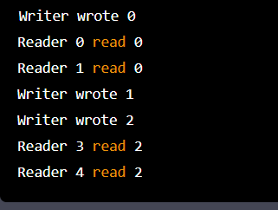

1. Dinning Philosopher problem using semaphore

Code:

#include <stdio.h>

#include <stdlib.h>

#include <pthread.h>

#include <semaphore.h>

#define NUM_PHILOSOPHERS 5

sem_t chopsticks[NUM_PHILOSOPHERS];

pthread_t philosophers[NUM_PHILOSOPHERS];

void *philosopher(void *arg)

{

int id = *(int*)arg;

int left = id;

int right = (id + 1) % NUM_PHILOSOPHERS;

while (1) {

printf("Philosopher %d is thinking\n", id);

sleep(rand() % 10);

printf("Philosopher %d is hungry\n", id);

sem_wait(&chopsticks[left]);

sem_wait(&chopsticks[right]);

printf("Philosopher %d is eating\n", id);

sleep(rand() % 10);

sem_post(&chopsticks[left]);

sem_post(&chopsticks[right]);

}

}

int main()

{

int i;

for (i = 0; i < NUM_PHILOSOPHERS; i++)

sem_init(&chopsticks[i], 0, 1);

for (i = 0; i < NUM_PHILOSOPHERS; i++)

pthread_create(&philosophers[i], NULL, philosopher, &i);

for (i = 0; i < NUM_PHILOSOPHERS; i++)

pthread_join(philosophers[i], NULL);

return 0;

}

Output:

